EXIT POLL FOR DEMO EVENTS

This exit poll can be used to gain feedback from the participants of your event, both on how they appreciated the organisation of the event and what they learned during the event.
Some questions may have to be adapted in accordance with your own event, notably questions 1 and 3.
Print the exit poll on paper and attach it to a clip board. Fill in while interviewing participants at the end of a demo event. Or use these questions for an online survey and send the link to the participants immediately after the demo event. Announce your request for them to fill in the exit poll during the closure of the event.

Authors: Herman Schoorlemmer, Ellen Bulten

Questions

- How did you learn about this demonstration event (tick box)?
☐ Personal invitation
☐ Farming press
☐ Website
☐ Social media
☐ Other:

- Why were you interested to visit this demo event?

- How do you appreciate the various aspects of the demo event (tick boxes)
(Items in the left column to be adapted according to the activities of the event)

 | Very useful | Useful | Neutral | Not useful
Lecture
Field walk
Workshop

- How was the demo event organized
Which aspects were well organised | Which aspects were not well organised
Why? | Why?

- What was the most interesting to you about this demo event?

- Which aspects of the demonstration(s) would be useful for your own farm and why?

- Do you have plans to apply what you witnessed today? Yes / No / Maybe
If you answered ‘Yes’ of ‘Maybe’, what might you apply?

- What are barriers to apply what you learned or saw today?

- Do you have any other suggestions?
Thank you very much, this survey will help us to improve the next demo events!
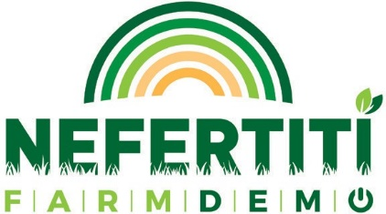
This project had received funding from the European Union’s Horizon 2020 research and innovation programme under grant agreement N°772705

NEFERTITI PARTNERS

MORE TOOLS ON
trainingkit.farmdemo.eu

